



Basics of Neural Network & Deep Learning Lab ENCA354

LAB FILE

SUBMITTED BY; SUBMITTED TO:
PAHVANI AGGARWAL Mr. Anoja Mishra

INDEX

SR.  NO. | EXPERIMENTS | PAGE NO. | TEACHER SIGN
01. | Neural Network using TensorFlow (Low-Level API) | 3-4
02. | Neural Network using Basic Python (From Scratch) | 5-7
03. | Neural Network using Keras | 8-10
04. | Agriculture Price Prediction (Regression Problem) | 11-12
05. | MNIST Digit Classification using ANN | 13-14
06. | Plant Disease Detection using CNN | 15-19

EXPERIMENT-1

Neural Network using TensorFlow (Low-Level API)

CODE:

import tensorflow.compat.v1 as tf
tf.disable_v2_behavior()

import numpy as np

X_data = np.array([[0,0],
[0,1],
[1,0],
[1,1]], dtype=np.float32)

Y_data = np.array([[0],
[1],
[1],
[0]], dtype=np.float32)

X = tf.placeholder(tf.float32, shape=[None, 2], name="X")
Y = tf.placeholder(tf.float32, shape=[None, 1], name="Y")

W1 = tf.Variable(tf.random_normal([2,4]), name="W1")
b1 = tf.Variable(tf.zeros([4]), name="b1")

W2 = tf.Variable(tf.random_normal([4,1]), name="W2")
b2 = tf.Variable(tf.zeros([1]), name="b2")

hidden = tf.nn.sigmoid(tf.matmul(X, W1) + b1)

output = tf.nn.sigmoid(tf.matmul(hidden, W2) + b2)

loss = tf.reduce_mean(tf.square(Y - output))

train = tf.train.GradientDescentOptimizer(0.1).minimize(loss)

with tf.Session() as sess:
sess.run(tf.global_variables_initializer())

for epoch in range(5000):
sess.run(train, feed_dict={X: X_data, Y: Y_data})

if epoch % 500 == 0:
l = sess.run(loss, feed_dict={X: X_data, Y: Y_data})
print("Epoch:", epoch, "Loss:", l)

result = sess.run(output, feed_dict={X: X_data})
print("\nPredicted Output:\n", result)

OUTPUT:

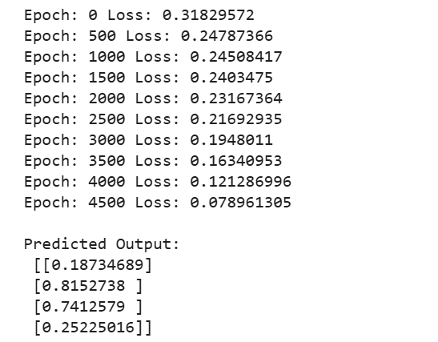

EXPERIMENT-2

Neural Network using Basic Python (From Scratch)

CODE:

import numpy as np

X = np.array([[0,0],

[0,1],

[1,0],

[1,1]])

Y = np.array([[0],

[1],

[1],

[0]])

np.random.seed(42)

input_neurons = 2

hidden_neurons = 4

output_neurons = 1

learning_rate = 0.1

epochs = 10000

W1 = np.random.randn(input_neurons, hidden_neurons)

b1 = np.zeros((1, hidden_neurons))

W2 = np.random.randn(hidden_neurons, output_neurons)

b2 = np.zeros((1, output_neurons))

def sigmoid(x):

return 1 / (1 + np.exp(-x))

def sigmoid_derivative(x):

return x * (1 - x)

for epoch in range(epochs):

hidden_input = np.dot(X, W1) + b1

hidden_output = sigmoid(hidden_input)

final_input = np.dot(hidden_output, W2) + b2

predicted_output = sigmoid(final_input)

loss = np.mean((Y - predicted_output) ** 2)

error = Y - predicted_output

d_output = error * sigmoid_derivative(predicted_output)

hidden_error = d_output.dot(W2.T)

d_hidden = hidden_error * sigmoid_derivative(hidden_output)

W2 += hidden_output.T.dot(d_output) * learning_rate

b2 += np.sum(d_output, axis=0, keepdims=True) * learning_rate

W1 += X.T.dot(d_hidden) * learning_rate

b1 += np.sum(d_hidden, axis=0, keepdims=True) * learning_rate

if epoch % 1000 == 0:

print("Epoch:", epoch, "Loss:", loss)

print("\nPredicted Output:")

print(predicted_output)

OUTPUT:

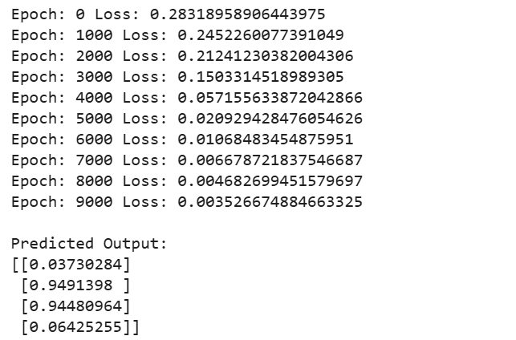

EXPERIMENT-3

Neural Network using Keras

CODE:

import tensorflow as tf
tf.compat.v1.enable_eager_execution()

import numpy as np
import matplotlib.pyplot as plt
from tensorflow.keras.models import Sequential
from tensorflow.keras.layers import Dense, Input

X = np.array([
[5.1,3.5,1.4,0.2],
[4.9,3.0,1.4,0.2],
[6.2,3.4,5.4,2.3],
[5.9,3.0,5.1,1.8],
[5.5,2.3,4.0,1.3],
[6.5,2.8,4.6,1.5]
], dtype=np.float32)

Y = np.array([
[1,0,0],
[1,0,0],
[0,0,1],
[0,0,1],
[0,1,0],
[0,1,0]
], dtype=np.float32)

model = Sequential([
Input(shape=(4,)),
Dense(10, activation='relu'),
Dense(8, activation='relu'),
Dense(3, activation='softmax')
])

model.compile(
optimizer='adam',
loss='categorical_crossentropy',
metrics=['accuracy']
)

history = model.fit(
X, Y,
epochs=50,
batch_size=2,
verbose=1
)

loss, accuracy = model.evaluate(X, Y)

print("Accuracy:", accuracy)
print("Loss:", loss)

plt.plot(history.history['accuracy'])
plt.title("Accuracy Graph")
plt.xlabel("Epoch")
plt.ylabel("Accuracy")
plt.show()

plt.plot(history.history['loss'])
plt.title("Loss Graph")
plt.xlabel("Epoch")
plt.ylabel("Loss")
plt.show()

OUTPUT:

Accuracy: 0.6666666865348816
Loss: 0.7614119052886963
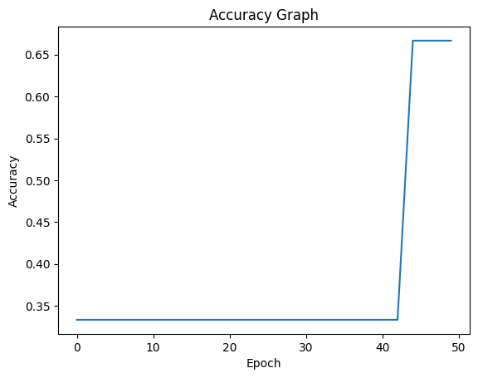
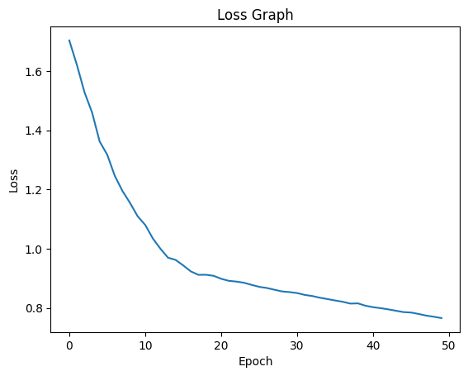

EXPERIMENT-4

Agriculture Price Prediction (Regression Problem)

CODE:-

import pandas as pd
import numpy as np
import tensorflow as tf
from tensorflow.keras.models import Sequential
from tensorflow.keras.layers import Dense
from sklearn.model_selection import train_test_split
from sklearn.preprocessing import StandardScaler
from sklearn.metrics import mean_squared_error, r2_score

url = "https://raw.githubusercontent.com/selva86/datasets/master/BostonHousing.csv"
data = pd.read_csv(url)

X = data.drop("medv", axis=1)
y = data["medv"]

X_train, X_test, y_train, y_test = train_test_split(
X, y, test_size=0.2, random_state=42
)

scaler = StandardScaler()
X_train = scaler.fit_transform(X_train)
X_test = scaler.transform(X_test)

model = Sequential([
Dense(64, activation='relu', input_shape=(X_train.shape[1],)),
Dense(32, activation='relu'),
Dense(1)
])

model.compile(optimizer='adam', loss='mse')

model.fit(X_train, y_train, epochs=100, batch_size=16, verbose=1)

y_pred = model.predict(X_test)

mse = mean_squared_error(y_test, y_pred)
r2 = r2_score(y_test, y_pred)

print("Mean Squared Error:", mse)
print("R2 Score:", r2)

OUTPUT:

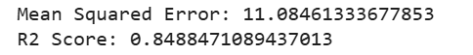

EXPERIMENT-5

MNIST Digit Classification using ANN

CODE:

import tensorflow as tf

from tensorflow.keras.models import Sequential

from tensorflow.keras.layers import Dense, Flatten

from sklearn.metrics import confusion_matrix

import numpy as np

(X_train, y_train), (X_test, y_test) = tf.keras.datasets.mnist.load_data()

X_train = X_train / 255.0

X_test = X_test / 255.0

model = Sequential([

Flatten(input_shape=(28,28)),

Dense(128, activation='relu'),

Dense(64, activation='relu'),

Dense(10, activation='softmax')

])

model.compile(

optimizer='adam',

loss='sparse_categorical_crossentropy',

metrics=['accuracy']

)

model.fit(X_train, y_train, epochs=5, batch_size=32, verbose=1)

loss, accuracy = model.evaluate(X_test, y_test)

print("Test Accuracy:", accuracy)

y_pred = model.predict(X_test)

y_pred_classes = np.argmax(y_pred, axis=1)

cm = confusion_matrix(y_test, y_pred_classes)

print("Confusion Matrix:")

print(cm)

OUTPUT:

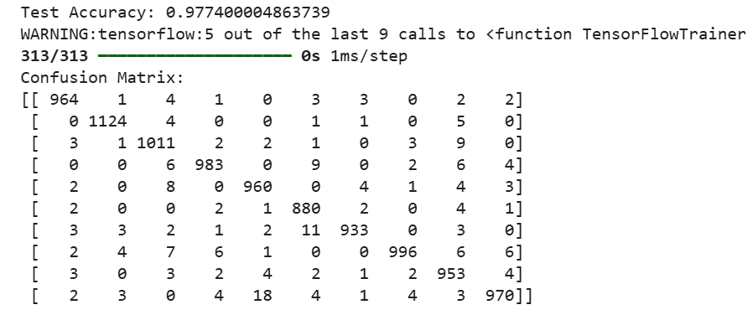

EXPERIMENT-6

Plant Disease Detection using CNN

CODE:

import tensorflow as tf

import matplotlib.pyplot as plt

import numpy as np

import os

import kagglehub

from tensorflow.keras.preprocessing.image import ImageDataGenerator, load_img, img_to_array

from tensorflow.keras.models import Sequential

from tensorflow.keras.layers import Conv2D, MaxPooling2D, Flatten, Dense, Dropout

dataset_path = kagglehub.dataset_download("emmarex/plantdisease")

print("Downloaded Dataset Path:", dataset_path)

data_directory = os.path.join(dataset_path, "PlantVillage")

image_width = 128

image_height = 128

batch_size = 32

epochs = 10

image_generator = ImageDataGenerator(

rescale=1.0 / 255,

validation_split=0.20

)

training_dataset = image_generator.flow_from_directory(

data_directory,

target_size=(image_width, image_height),

batch_size=batch_size,

class_mode='categorical',

subset='training',

shuffle=True

)

validation_dataset = image_generator.flow_from_directory(

data_directory,

target_size=(image_width, image_height),

batch_size=batch_size,

class_mode='categorical',

subset='validation',

shuffle=True

)

print(training_dataset.class_indices)

cnn_model = Sequential()

cnn_model.add(Conv2D(

filters=32,

kernel_size=(3, 3),

activation='relu',

input_shape=(128, 128, 3)

))

cnn_model.add(MaxPooling2D(pool_size=(2, 2)))

cnn_model.add(Conv2D(

filters=64,

kernel_size=(3, 3),

activation='relu'

))

cnn_model.add(MaxPooling2D(pool_size=(2, 2)))

cnn_model.add(Conv2D(

filters=128,

kernel_size=(3, 3),

activation='relu'

))

cnn_model.add(MaxPooling2D(pool_size=(2, 2)))

cnn_model.add(Flatten())

cnn_model.add(Dense(units=128, activation='relu'))

cnn_model.add(Dropout(0.5))

cnn_model.add(Dense(

units=training_dataset.num_classes,

activation='softmax'

))

cnn_model.compile(

optimizer='adam',

loss='categorical_crossentropy',

metrics=['accuracy']

)

cnn_model.summary()

training_history = cnn_model.fit(

training_dataset,

validation_data=validation_dataset,

epochs=epochs

)

cnn_model.save("plant_disease_detection_model.h5")

plt.figure(figsize=(10, 5))

plt.plot(training_history.history['accuracy'], label='Training Accuracy')

plt.plot(training_history.history['val_accuracy'], label='Validation Accuracy')

plt.title("Model Accuracy")

plt.xlabel("Epochs")

plt.ylabel("Accuracy")

plt.legend()

plt.show()

plt.figure(figsize=(10, 5))

plt.plot(training_history.history['loss'], label='Training Loss')

plt.plot(training_history.history['val_loss'], label='Validation Loss')

plt.title("Model Loss")

plt.xlabel("Epochs")

plt.ylabel("Loss")

plt.legend()

plt.show()

test_image_path = "test_leaf.jpg"

if os.path.exists(test_image_path):

test_image = load_img(

test_image_path,

target_size=(128, 128)

)

test_array = img_to_array(test_image)

test_array = np.expand_dims(test_array, axis=0)

test_array = test_array / 255.0

prediction = cnn_model.predict(test_array)

class_labels = list(training_dataset.class_indices.keys())

predicted_class = class_labels[np.argmax(prediction)]

print("Predicted Disease:", predicted_class)

else:

print("No test image found.")

OUTPUT:

Using Colab cache for faster access to the 'plantdisease' dataset.

Downloaded Dataset Path: /kaggle/input/plantdisease

Found 16516 images belonging to 15 classes.

Found 4122 images belonging to 15 classes.

Disease Classes:

{'Pepper__bell___Bacterial_spot': 0, 'Pepper__bell___healthy': 1, 'Potato___Early_blight': 2, 'Potato___Late_blight': 3, 'Potato___healthy': 4, 'Tomato_Bacterial_spot': 5, 'Tomato_Early_blight': 6, 'Tomato_Late_blight': 7, 'Tomato_Leaf_Mold': 8, 'Tomato_Septoria_leaf_spot': 9, 'Tomato_Spider_mites_Two_spotted_spider_mite': 10, 'Tomato__Target_Spot': 11, 'Tomato__Tomato_YellowLeaf__Curl_Virus': 12, 'Tomato__Tomato_mosaic_virus': 13, 'Tomato_healthy': 14}

/usr/local/lib/python3.12/dist-packages/keras/src/layers/convolutional/base_conv.py:113: UserWarning: Do not pass an `input_shape`/`input_dim` argument to a layer. When using Sequential models, prefer using an `Input(shape)` object as the first layer in the model instead.

super().__init__(activity_regularizer=activity_regularizer, **kwargs)

Model: "sequential"

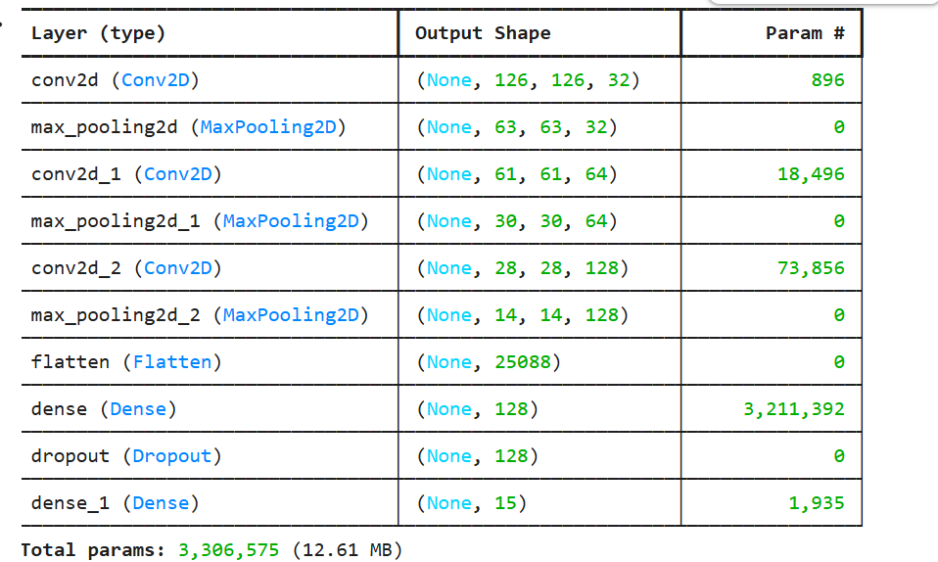

Total params: 3,306,575 (12.61 MB)

Trainable params: 3,306,575 (12.61 MB)

Non-trainable params: 0 (0.00 B)

